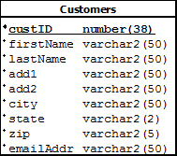

Database

Server Side

Client Side

Called From:

“Delete” link in for the record in read.jsp

Return to DeleteServlet after record has been deleted.

Set up DeleteQuery Object

Pass custID(pk)

read.jsp

Table

|  |  |  |  |  |  |  |  |  |  |
| --- | --- | --- | --- | --- | --- | --- | --- | --- | --- |
| CustID | First Name | Last Name | Add1 | Add2 | City | State | Zip | EamilAddr | Update  Delete |
|  |  |  |  |  |  |  |  |  |  |

Add New Customer

Read Request

ReadServlet

DeleteServlet

ojdbc6.jar

Driver

DeleteQuery

Create db connection

Create Prepared Statement

Set up Prepared Statement with query

Send query to delete record from db

db Conn.properties

driver name=

server name=

user name=

user password=